Fair and Insightful AI for E-Commerce: Bias Mitigation in Sentiment Models and Topic Modeling of Multilingual Amazon Customer Reviews
Customer reviews are important in determining the business strategy and consumer confidence in global e-commerce but models of sentiment analysis do not normally run well in different languages resulting into discriminatory and unreliable information. In this project, language-based bias is explored in relation to multilingual sentiment classification of Amazon reviews and how these disparities influence the perception of global customer feedback in six languages i.e., English, Chinese, French, Japanese, German, and Spanish. A combined analytical system is designed that integrates the sentiment classification models with the bias detection and mitigation schemes to achieve fair performance in both high and low resource languages. Topic modeling is also added to aid in better interpretation by viewing the drivers behind customer sentiment, associating emotional polarity with certain product and service aspects. The project will result in a business intelligence dashboard that will show fair sentiment metrics and cross-linguistic insights that will facilitate the transparent and ethical and data-driven decision-making in the global e-commerce setting.
Key Words: Multilingual Sentiment Analysis, Bias Detection, Bias Mitigation, Topic Modeling, Ethical AI
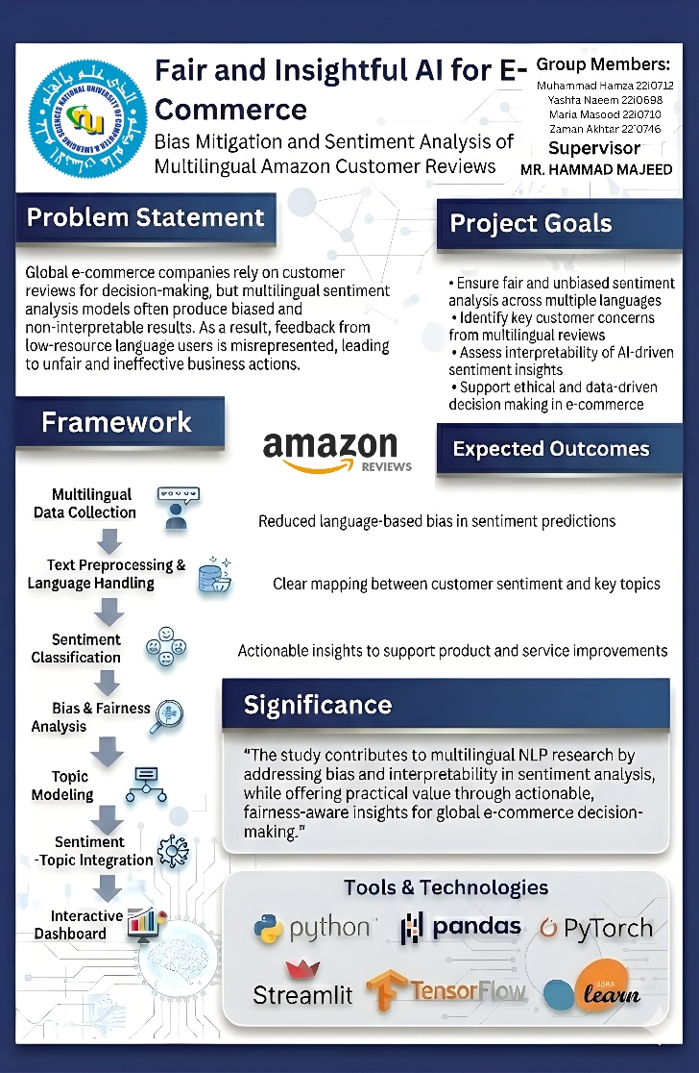

Area of Study:
Business Analytics
Supervisor Name:
Mr. Hammad Majeed
Group Members:
Muhammad Hamza (i22 - 0721)
Yashfa Naeem (i22 - 0698)
Maria Masood (i22 - 0710)
Zaman Akhtar (i22 - 0746)

